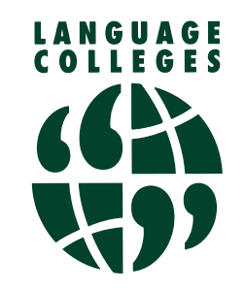Registration Form Primary & Secondary Classes - 2022 / 2023
Alderman White School/ White Hills Park Trust
Language College
Mr K Stephan – Director of Language College
Tel: 0115 9175944
https://aldermanwhite.school
languages@aldermanwhite.school
Chilwell Lane, Bramcote, Nottingham NG9 3DU

Class/Language:
Day & Time:
Surname:

First name:

School:

Year

Date of Birth:

Address:

Post code:
Parental Contact Details
Home Telephone number:
Mobile number:

E-Mail Address:

Medical Details of which staff should be aware

Lessons cost from £6.00 per session in a class of 6 + persons. Please refer to the programme for further details. Some classes will be face-to face, others maybe be online or a mixture of the two. We operate a ‘Pay-as-you-learn’ scheme with half termly payments (6 weeks) requested in advance by BACs or cheque. Payment is required for all weeks unless a lesson is cancelled. Should the number drop below 6 people, we may have to increase the cost per session. All information requested on this form is required to support your child during their attendance at the school for the language classes. Please complete this form in full referring to the GDPR Privacy Notice enclosed explaining why we collect and how we use this information. If you have any questions please do not hesitate to contact us.. I have read the above and accept the conditions relating to the course.

Signature of Parents/Carers/Guardians

Signed: Date:

Name: __________________________________________

